Graph showing class Vs number of images.

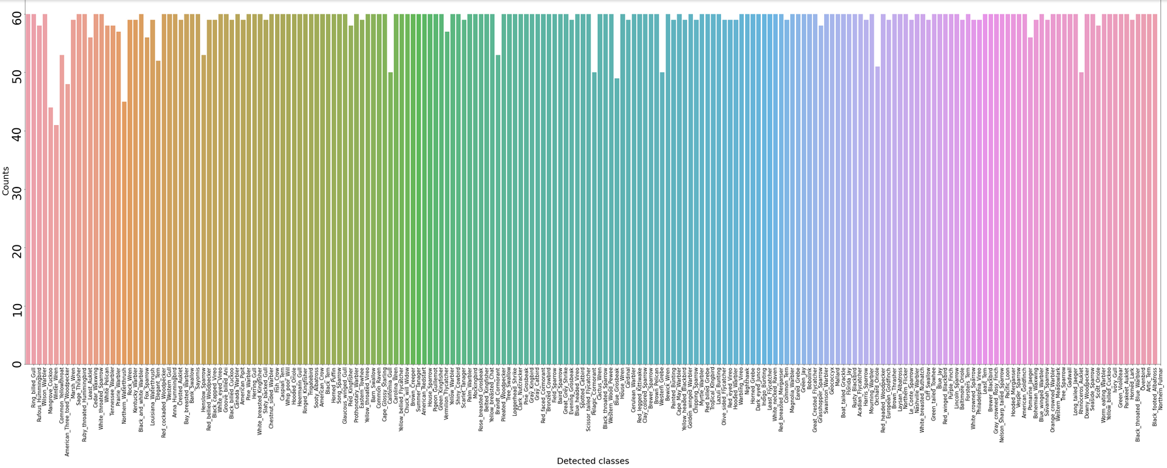

The total number of images are **11788** which are divided into **200** classes (200 types of birds)



There are many classes with the highest number of images, the max number of images for a class is **60**.

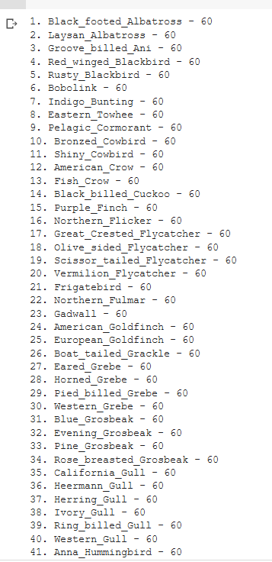

The lowest number of images for a class is **41** and the class name is Least_Auklet



The average number of images for a class is **59**



**the dataset is divided into 50.85% train set and 49.15% test set**

number of images in trainset = 5994

number of images in testset = 5794

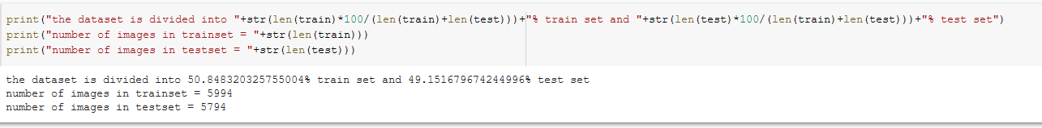

The max number of images for a class in **training data** is 30

The min number of images for a class in **training data** is 29 and the class names are:

House_Wren, Red_cockaded_Woodpecker, Artic_Tern, Bank_Swallow, Nelson_Sharp_tailed_Sparrow, Common_Raven.

All the other classes in the training data have 30 images

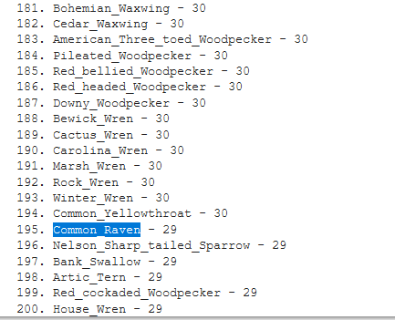

The max, min number of images for a class in **testing data** are 30, 11 respectively

The 11 images are present for the class **Least_Auklet** while there are many classes with 30 images in the testing set



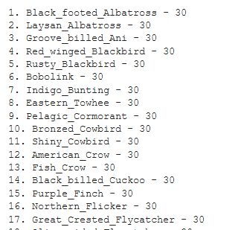

We are also given bounding box for every image, the bounding box contains the **image ID x,y co-ordinates** and **width and height** of the image. So instead of using the whole image for training we can use only the part of this bounding box.

Every image has different bounding box.

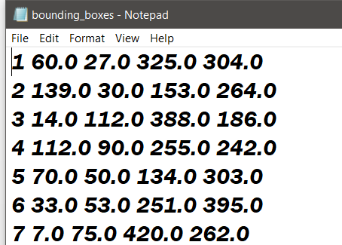

Apart from this we are also given 312 attributes, each image contains atleast one of this attribute but it can also contain all the attributes, this is given in the format **attribute_ID , attribute_name**

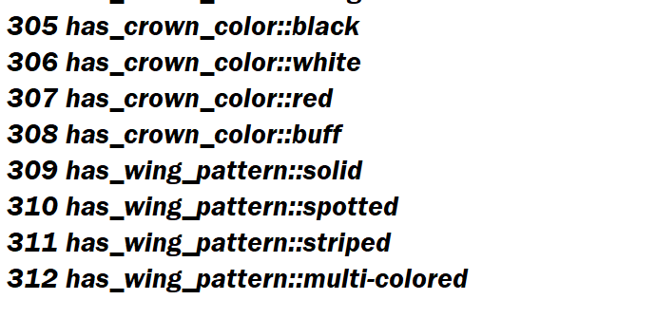

We are also given how visible the attribute is present in a picture, the given format is **certainity_ID, certainity_name**

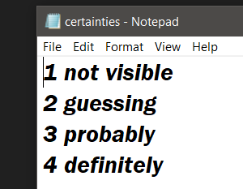

And here we are given the **image id, attribute id, is_present** (1- present 0-not present), **certainity id, Time**

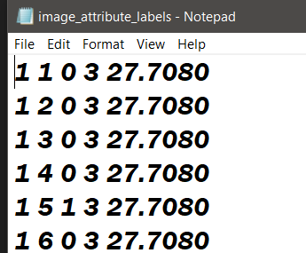

Using this table we can identify which attributes are present in an image and extract them. The time denotes the time taken my **Mturker** to identify a particular attribute in an image. Since we are also given the bounding box for each image we can try to find this attribute in that bounding box rather than the whole image.